OUUC COVID PANDEMIC MANUAL
November 5, 2020
Revised July 29 and December 16, 2021

TABLE OF CONTENTS

Section 1. Introduction ............................................................................................................ 3
Document Revision, December 2021
Document Revision, July 2021
The OUUC Health and Safety Taskforce
The State of Washington: A Model for the Work of the Taskforce
Section 2. A New Agreement for These Difficult Times ....................................................... 5
OUUC Agreement for Times of Pandemic
Section 3. OUUC Comprehensive COVID-19 Exposure Control, Mitigation,
and Recovery Plan ..................................................................................................... 6

1) PPE Utilization
2) Physical Distancing
3) Hygiene
4) Sanitation
5) Symptom Monitoring
6) Incident Reporting
7) Location Disinfection Procedures
8) Covid-19 Safety Training
9) Exposure Response Procedures
10) Post-exposure Incident Project-wide Recovery Plan
11) Miscellaneous
Section 4. Situational Protocols ............................................................................................. 12
1) Outside Protocol
2) Inside Protocol
3) Bathroom Protocol
Section 5. Appendix: Educational Materials ..........................................................................15

SECTION 1. INTRODUCTION
Document Revision, December 2021
Since the July revision of this document (see below), a number of important changes in the arena of responsiveness to the Covid-19 pandemic have taken place:
- Throughout this country, state, county, and the City of Olympia, a concerted effort to vaccinate the populace has resulted in vaccination rates that range from 66% (Thurston County) to 72% (state of Washington). The OUUC Health & Safety Team anticipates that the vaccination rate in the congregation is quite high.
- OUUC began to use the overall, color-coded risk category system and metrics for Thurston County from CovidActNow.org, which in turn accesses current data reporting from Thurston County, the CDC, the Department of Health & Human Services, and other sources. ActNow uses three metrics to determine risk level: New Daily Cases (per 100,000), Infection Rate, and Positive Test Rate. OUUC also follows state and county guidelines and mandates.
The Health & Safety Team issued the Olympia Unitarian Universalist Congregation Phased Reopening Plan, detailing the activities acceptable in each risk phase, which is to be used in conjunction with this pandemic manual. OUUC now provides the congregation with a report of current risk level once a week.
- The guidance from the Center for Disease Control (CDC) and the Washington State Department of Health regarding appropriate precautions to be taken by individuals and institutions has evolved significantly.
Consequently, the Health & Safety Team has revised this manual in accordance with both the change in our guidance and the impact of the Covid-19 vaccines on the dynamics of the illness and its spread.
The Health & Safety Team and OUUC staff expects that users of the OUUC building and facilities to continue to closely follow the guidance provided here regarding means of reducing the likelihood of disease transmission, including wearing mask, social distancing, and sanitation procedures. In addition, we urge everyone who can do so to become fully vaccinated against Covid as soon as possible.

Document Revision, July 2021
The Health & Safety Team undertook a revision of this OUUC Pandemic Manual in July 2021 in response of the changes in the state of Washington’s guidance regarding the Covid-19 pandemic put in place at the end of June and the latest recommendations from the Center for Disease Control and the state regarding masking. The intention is to be both as inclusive as possible and to protect all of our community, including children and others not yet fully vaccinated, those fully vaccinated who are immune compromised and therefore may not be fully protected, and those choosing not to vaccinate. While the directives regarding social distancing and the wearing of masks (and related subjects) have been changed, we honor every individual’s choices for their own safety, comfort, and ease.
We continue to strongly recommend that anyone having symptoms of illness or recent exposure to a virus stay home and access the church’s online resources to attend services and other streamed events.
The OUUC Health and Safety Taskforce
In early 2020, the OUUC Board of Trustees appointed a taskforce of seven people, representing various aspects of life in our community, initially to study building capacity. With the onset of the virus the taskforce, now called the Health and Safety Taskforce, was given a new charge by the Board to develop a plan, procedures, and protocols for church operations and use during the COVID-19 pandemic. The Board’s charge to the group, as revised in June, includes:
This group is charged to work with the minister, Caretaker and other staff to address building use during the pandemic in a way that lives up to the OUUC mission, remains true to Unitarian Universalist values and principles, and is in line with public health guidance. While we recognize that the minister is ultimately responsible for operational decisions, we believe that response to this unprecedented situation requires our collective wisdom, and we want a deliberative, informed and spiritually grounded response.
The State of Washington: A Model for the Work of the Taskforce
The initial priority of the taskforce was to find a model for response to the pandemic that would help us determine and respond to the many issues that need to be addressed. We recognized that to follow any one model may mean taking actions that may be different from individual preferences. But, the safety of the community is our top priority; we also must be inclusive, providing ways for people to participate in person or virtually.
After some deliberation and study, the Taskforce has recommended that we at OUUC commit to following the requirements, guidance, and protocols issued by the State of Washington for all activities and events that may occur in and about our church and grounds during the pandemic. The state’s document, Phase 1, Phase 2, and Phase 3 Religious and Faith-based Organization COVID-19 Requirements (updated 08/10/2020) provides clear and extensive guidance regarding our responsibilities. It includes the following directive:
Prior to beginning operations as described in this document, all religious and faith-based organizations are required to develop for each location (indoor and outdoor if applicable) a comprehensive COVID-19 exposure control, mitigation and recovery plan. The plan must include policies regarding the following control measures: PPE utilization; on-location physical distancing; hygiene; sanitation; symptom monitoring; incident reporting; location disinfection procedures; COVID-19 safety training; exposure response procedures and a post-exposure incident project-wide recovery plan.
This manual provides OUUC’s response to that directive.

SECTION 2. A NEW AGREEMENT FOR THESE DIFFICULT TIMES
The Health and Safety Taskforce felt that to protect our community we need a new, mutual agreement, one that is specific to pandemic conditions. It drafted and approved an OUUC Agreement for Times of Pandemic, as follows.
OUUC Agreement for Times of Pandemic
Unitarian Universalism is a covenantal faith grounded in the belief that we are all connected and the practice that we make explicit agreements about how to be together. We affirm that our covenants are guided by science and our values.
We, the members, friends and staff of the Olympia Unitarian Universalist Congregation do affirm that extraordinary times, such as the era of the 2020 Covid-19 pandemic, call for an explicit and extraordinary agreement as to appropriate behavior among us.
We recognize that our actions directly impact the health and well-being of others. We acknowledge that COVID-19 disproportionately affects people with disabilities, Black people, Indigenous communities, Latinx people, the elderly, and essential workers, a majority of whom are women and women of color. We know that as a religious community, we have a moral responsibility to do all we can to reduce risks for those already at such high risk.
For that purpose, we agree that:
* Because our preeminent concern is for the health and safety of the community...
we will follow the guidance provided by the minister and staff regarding use of the building and grounds that reflects the known science and best practices to promote health and safety as gathered by congregational advisory groups, such as the Capacity Task Force. Such practices include, but are not limited to, use of masks, social distancing guidelines, room and group capacities, and symptom monitoring. In the absence of such guidance, we will follow that provided by the State of Washington’s governor and Department of Health.
* Because we choose to walk together we promise to…
accept the responsibility to stay abreast of guidance from the church regarding the best practices to promote health and safety by frequently monitoring church information sources (website, Wednesday Newsletter, and onsite signage). When in doubt we will consult with staff.
We also reaffirm the OUUC Covenant, with special reference to the following portions:
* Because we need not think alike to love alike, we promise to…
speak and work openly, honestly, and lovingly with our leadership, providing informed,
constructive feedback when we believe change is needed.

* Because we recognize that conflict is normal we promise to…
speak with each other directly and honestly from a position of respect, kindness and love, recognizing that to do so, there will be times we need to seek counsel from the community.

SECTION 3. OUUC COMPREHENSIVE COVID-19 EXPOSURE CONTROL, MITIGATION, AND RECOVERY PLAN
The OUUC COVID plan has been constructed on an underlying assumption that everyone will take responsibility for following personal preventive procedures. Everyone will:
Stay home if sick, if a household member is sick, or until you have received a negative test for Covid if you have been exposed to someone with the illness.
Honor each other’s need for adequate personal space
Wear a face mask or other approved protection over the nose and mouth indoors; masks are recommended outdoors in large gatherings.
Cover coughs or sneezes
Wash hands frequently
Wipe down surfaces after use
The OUUC policies regarding exposure control, mitigation, and recovery required by the State of Washington are as follows:

1) PPE Utilization: Masks and Gloves
Refer to the OUUC Phased Reopening Guidelines available on the OUUC website for the use of masks inside the building.
Masks outside are optional, but everyone is encouraged to wear a mask in larger groups.
Strategies for wearing face covering are discussed in the Guidance on Cloth Face Coverings from the Washington State Department of Health (Updated May 21, 2021).
Anyone who cleans the church, including OUUC maintenance staff, shall wear gloves, mask and eye protection.
2) Physical Distancing
Social distancing inside the church building is strongly recommended. Seating will be managed such that the recommended 6 feet of spacing for those not of the same household is provided in the Sanctuary and other meeting spaces.
3) Hygiene
Tissues and trashcans must be placed inside and outside the church.
Soap and running water shall be provided at multiple locations to allow for frequent hand washing. Everyone should be encouraged to wash their hands regularly, and required to do so after going to the bathroom, before and after eating and after coughing, sneezing or blowing their nose. Alcohol-based hand sanitizers with greater than 60% ethanol or 70% isopropanol should also be provided for use.
4) Sanitation
Disinfectants must be available to staff, members, and visitors inside and outside the church.
High-touch surfaces, including personal work stations, doorknobs, handrails, restrooms and meeting rooms, must be cleaned and disinfected with the appropriate disinfectants after each use.
5) Symptom Monitoring
Individuals in the OUUC building and on the property should not be capable of transmitting COVID. Admission to the building will be permitted only if all screening reveals no symptoms. Staff, members, and visitors should self-screen for signs and symptoms of COVID-19 before arriving at the church.
Individuals who, in the past 14 days, have either tested positive for viral presence for COVID or had recent new symptoms consistent with COVID (such as sore throat, runny nose, sneezing, congestion fever or chills, cough, breathlessness, loss of taste/smell, muscle aches, headaches, fatigue nausea, vomiting, or diarrhea) should quarantine at home and follow Washington State Department of Health guidance (See What to do if you test positive for Covid-19 at https://www.doh.wa.gov/Portals/1/Documents/1600/coronavirus/COVIDcasepositive.pdf.)
Individuals who have had recent exposure to a confirmed or suspected case of COVID are expected to stay away from church for fourteen days or until they have received a negative test result for the disease 4-7 days following exposure, whether or not they have been fully vaccinated.
Procedures for response to the contamination of OUUC facilities are outlined in later sections of this plan.
6) Incident Reporting
By law, doctors and labs must report cases of COVID-19 to the local health jurisdiction (for OUUC, the Thurston County Health Department), after which contact tracing begins. Guidance regarding dealing with known or suspected cases of the virus is based on the idea of isolating the suspected case (whether exhibiting symptoms or known exposure) at home and encouraging them to seek medical help, including testing and contact with a doctor.
Religious organizations are not required by law to report cases of COVID-19, but OUUC will notify the Thurston County Health Department if we suspect an outbreak among church staff or congregants.
7) Location Disinfection Procedures
Disinfectants must be available to employees, members, and visitors throughout the location (indoor and outdoor) and cleaning supplies must be frequently replenished. Clean and disinfect high-touch surfaces after each use—including offices, doorknobs, handrails, restrooms, and breakrooms—using soapy water, followed by the appropriate disinfectants.
8) Covid-19 Safety Training
The following groups have been identified as needing specific COVID safety training:

OUUC staff
Group (committees and teams, work parties, special events) leaders
Group (committees and teams, work parties, special events) members
Attendees of services
Service volunteers (greeters, ushers, servers, celebrants)
Choir members and musicians
The general public (visitors, casual users)

Training procedures for these groups should include:

All groups:
Pre-arrival self-screening procedures and criteria
Nature of airborne transmission of particles
General safety procedures (hand washing and sanitizer, personal protective gear, avoiding high risk situations)
Outside Protocol
Inside Protocol
Bathroom Protocol

Administrative Staff
Tracking building use and activity; record keeping
Interface with county and state health departments
Issues of confidentiality

Maintenance Staff
Cleaning and maintenance procedures for facilities
Use of signage and other educational materials for congregation
Appropriate hygiene equipment and supplies for building users
Personal protection gear for staff
Procedures for optimizing airflow in the building

Group leaders
Scheduling use of building
Records keeping of group participants
Orientation/education of group members

Group members
Building access

Ushers, Greeters
Use of personal protective equipment
Appropriate guidance for attendees

Food Service volunteers
Clean up before and after events
Disposal/decontamination of materials and equipment

Visitors
Process of building entry and use
Signing in
Permission to share attendance information with health department

9) Exposure Response Procedures
In the event that possible exposure to COVID-19 occurs at OUUC, staff shall initiate the following procedures:
* Identify staff, members and visitors who might have been exposed at church.
* Review logs, databases, and video footage, and interview staff to provide data to the authorities for contact tracing.
* Inform exposed staff of their possible exposure to COVID-19 in the workplace, but maintain confidentiality as required by the Americans with Disabilities Act.
* Instruct anyone with close, direct contact to stay home for 14 days quarantine, self- monitor for symptoms, and get tested for SARS-CoV-2 per the CDC’s Recommendations for Community-Related Exposure and the Washington State guidance concerning response to exposure. Fully vaccinated individuals should self-monitor for symptoms and stay away from church for 14 days or until receiving a negative test for Covid-19.
* Ensure that all staff and visitors are prescreened for symptoms prior to entry to the building. Consider a single point of entry to more easily complete screening but ensure social distancing if people must wait to be screened.
* Inform the congregation as appropriate. Be transparent about confirmed cases and close contacts while protecting confidentiality. Explain steps being taken to reduce transmission and reinforce any particular actions that should be taken to stay safe. Provide information about where to get additional information for any questions or concerns.
* Maintain a list of confirmed and any suspected cases among staff, members and visitors, and a list of all exposed people. Be prepared to share these lists with Thurston County Public Health.

In addition, in the event of a likely case of COVID in staff, congregants, or visitors to the church building, the OUUC shall take the following steps to reduce the risk of subsequent transmission of COVID to baseline (low) levels. The actions should be initiated within 24 hours and completed within 72 hours.

(a) Administrative actions:

Restrict access to the building until it has been thoroughly cleaned;
Provide information on potential contacts to Thurston County Health Department; obtain written permission of congregants before names are released;
Recommend self-quarantine and testing for likely exposed individuals, as determined by
Health Department staff and other church advisors.

(b) Physical actions:

Trace movements of infectious individuals in the building;
Provide cleaning staff with suitable protective equipment and supplies for deep cleaning;
Ventilate, clean and disinfect area of impact according to procedures outline in “PPE utilization,” “Sanitation,” and “Location Disinfection Procedures” above;
Dispose of PPE and other items as directed;
Clean and disinfect all cleaning equipment.
10) Post-exposure Incident Project-wide Recovery Plan
In order to prepare the building for use after a confirmed Covid-19 case or outbreak, the following steps should be taken:
Limit access to the building for a period of time to allow for cleaning (48 hrs or per Thurston County Health Department recommendation);

Implement health department recommendations for building access, quarantine, and education of congregants.

Remove infection material (fomites) from surfaces by cleaning and disinfection by church staff or by a qualified contractor.

11) Education
The OUUC Pandemic Manual and the Situational Protocols for activity outside and inside the church building and in the bathrooms shall be made available to all staff, members of the congregation and visitors through the OUUC website.
In addition, COVID-19 safety information and requirements, such as CDC, DOH, and OSHA posters shall be posted throughout and outside the church.

SECTION 4. SITUATIONAL PROTOCOLS
The following three protocols for activity at OUUC outside the building, inside the building. and in the bathrooms have been developed from the guidance incorporated in the OUUC Comprehensive COVID-19 Exposure Control, Mitigation, and Recovery Plan. In addition, stand-alone documents of each of the protocols, for use as posters and handouts, are in the Appendix.
1) Outside Protocol
No one should be on church grounds if they have new or unexplained health symptoms.
If you or someone in your household is sick and may be contagious – stay home!
If you are in self-quarantine – stay home!

Work parties or individuals at the church must have access to hand sanitizer and sanitizing wipes.
Work parties or individuals must keep a record of those working on the church grounds for three weeks in case it is needed for contact tracing.
Mask wearing outside is optional but recommended in large gatherings.
Work parties or individuals are strongly urged to wear work gloves while on church grounds.
Anyone entering the church building must sign in and follow all posted requirements.
Anyone organizing a work party on church grounds must distribute the above information to all potential participants, must assure that hand sanitizer and sanitizing wipes are available, and must keep a list of people who are at the church for a period of least three weeks.
Anyone who tests positive for COVID and has been on OUUC premises in the prior two weeks must notify the church administrator.
2) Inside Protocol
No one should be on church grounds if they have new or unexplained health symptoms.
If you or someone in your household is sick and may be contagious – stay home!
If you are in self-quarantine – stay home!

The church building shall remain locked at all times when not occupied. Anyone who opens the building for group use must:
* schedule the meeting with the church administrator beforehand;
* document the names of all those who enter the building and retain the list for 3 weeks;
* sanitize all surfaces that have been touched after occupancy, including handles of doors and windows; open appropriate doors and windows to increase ventilation when possible.
* inform all participants of options regarding personal health appraisal, spatial distancing, and wearing of masks by drawing attention to displays of COVID-19 signage and distributing this handout;
* ensure that all doors and windows are closed and locked upon departure;
* report any concerns regarding the health of occupants to the church administrator.
Materials for sanitizing of surfaces, including sanitizing cleaners, gloves, and hand sanitizer will be available at several locations throughout the building. All surfaces that have been touched, including table tops, chairs, door and window handles, light switches, and toilet seats should be sprayed with a sanitizing cleaner and then wiped vigorously with a paper towel after sixty seconds.
No food may be consumed in the building. The kitchen may only be used for plating of individual servings and cleanup. Servers and prep crew must wear masks and gloves. The water fountains are turned off. Everyone is encouraged to bring their own water bottle.
3) Bathroom Protocol
No one should be on church grounds if they have new or unexplained health symptoms.
If you or someone in your household is sick and may be contagious – stay home!
If you are in self-quarantine – stay home!

Please use the single-stall restrooms across from the main restrooms and in the RE wing. The main restrooms will be opened temporarily by staff for large special events, such as the church picnic, but otherwise will remain closed.
Sanitize your hands when entering the building, and keep your mask on.
Close toilet lid before flushing.
After washing your hands, you can use the paper towel to turn off the water and open and close the door.
Dispose of paper towel in receptacle outside door.

SECTION 5. APPENDIX: EDUCATIONAL MATERIALS
Three documents have been created for posting in appropriate locations around the church and for providing to group leaders for sharing with their attendees.
- OUUC Pandemic Protocol for Being Outside at Church
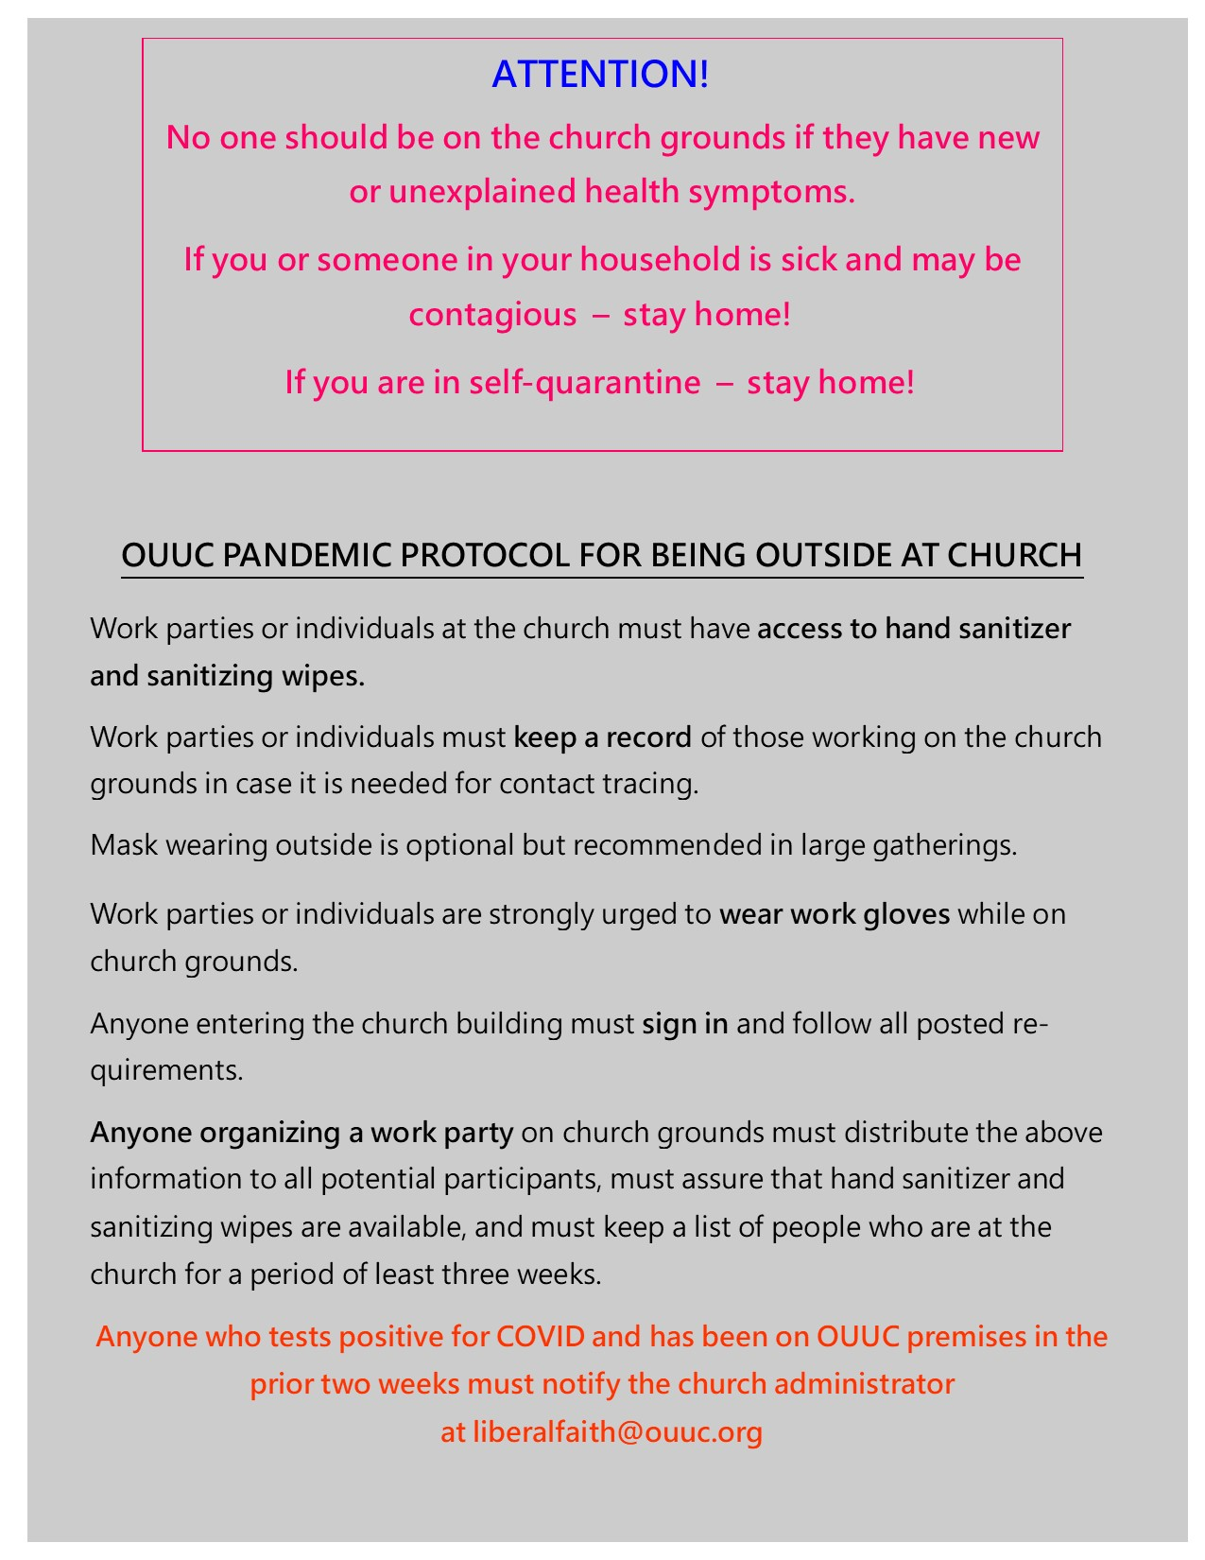
- OUUC Pandemic Protocol for Use of the Church Building
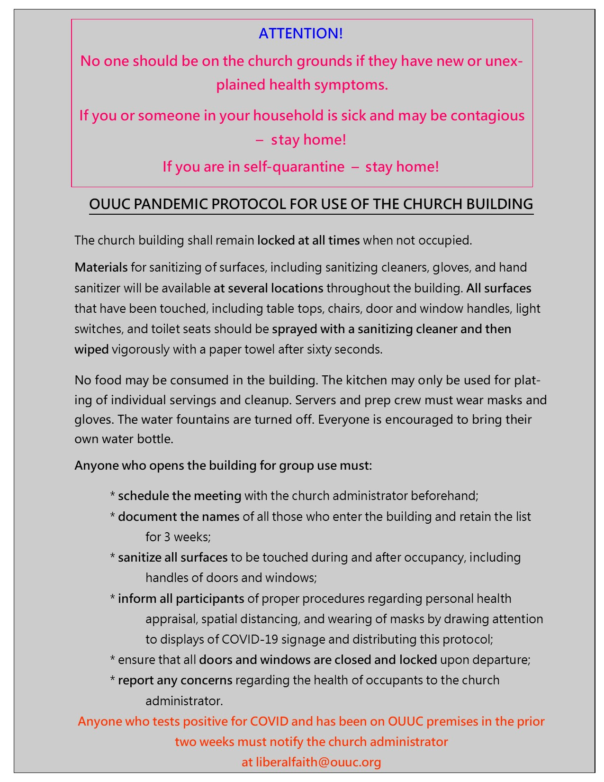
- OUUC Pandemic Protocol for Use of Bathrooms
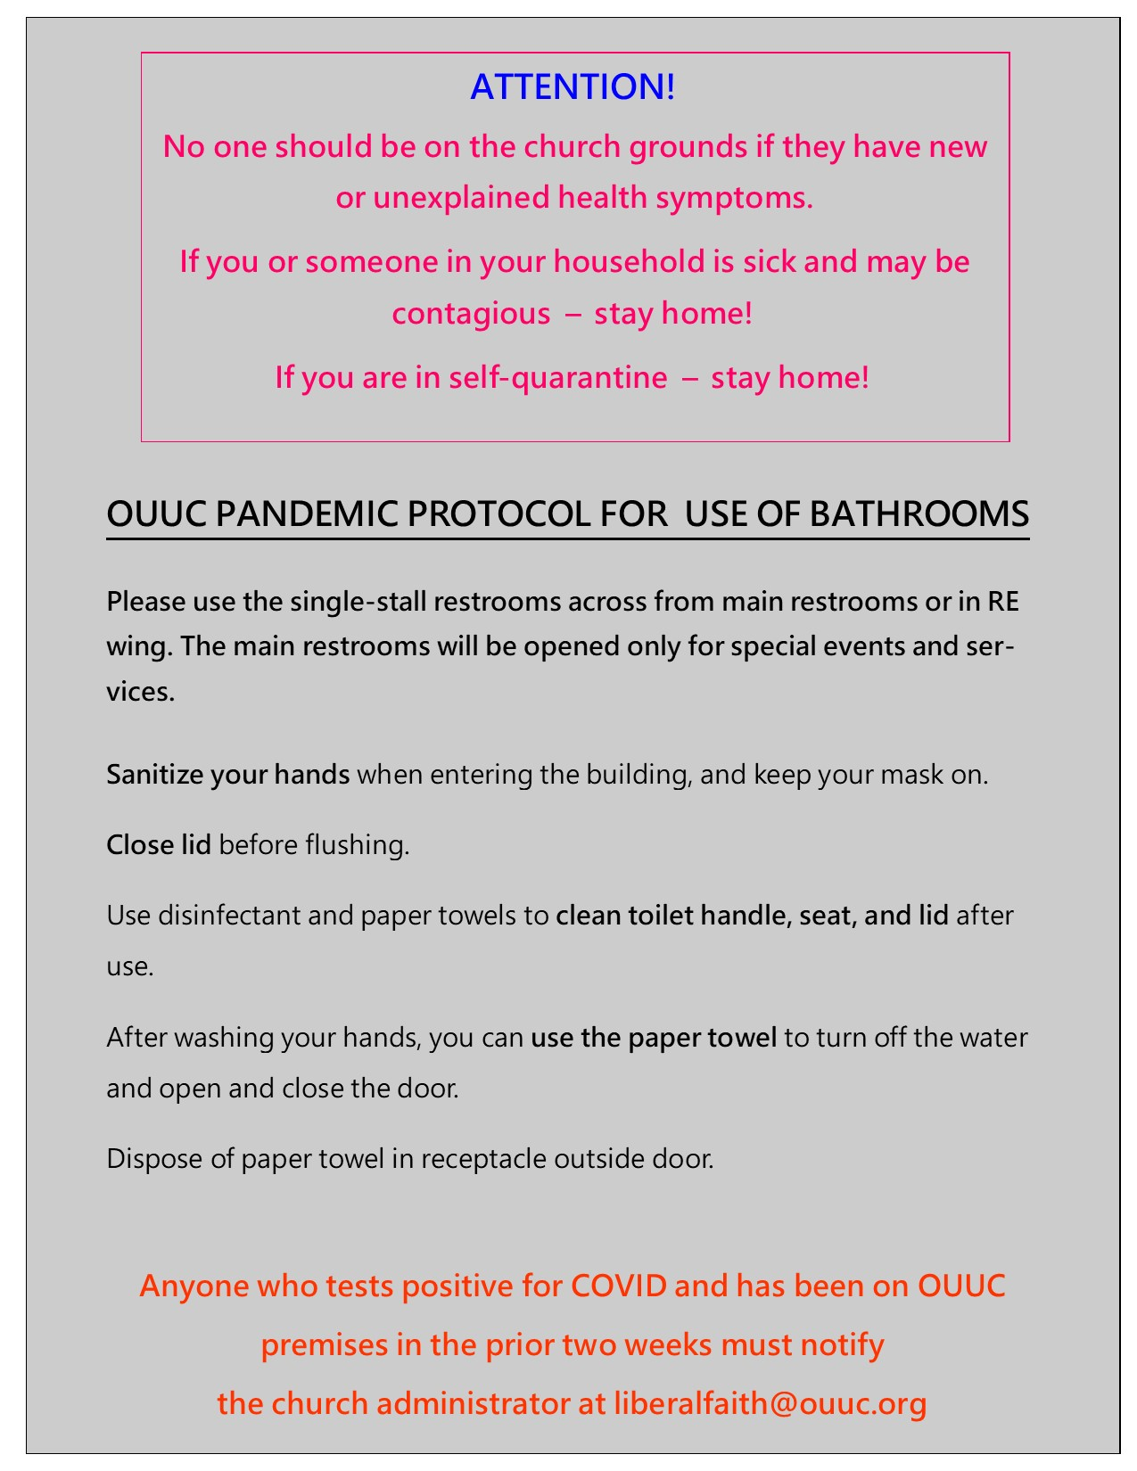

https://www.doh.wa.gov/Portals/1/Documents/1600/coronavirus/ClothFacemasks.pdf
A close contact is any person who was within 6 feet of a contagious COVID-19 case for at least 15 minutes. A person is contagious 2 days before their illness onset (or, for asymptomatic patients, 2 days before a positive test was collected) until the time they are isolated.
https://www.cdc.gov/coronavirus/2019-ncov/php/public-health-recommendations.html
https://www.doh.wa.gov/Portals/1/Documents/1600/coronavirus/COVIDexposed.pdf

